Ms. Nchogu is a Film Independent Producing fellow.

Production Coordinator: Wanjiru Kimundu
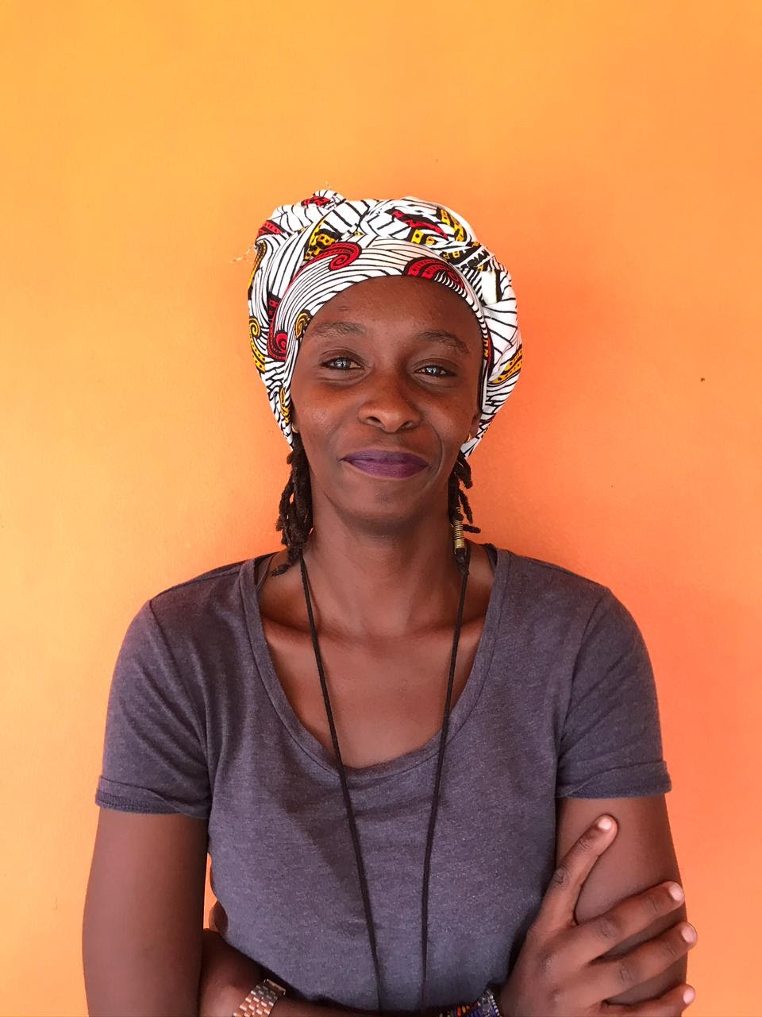
Wanjiru is the in-house Producer and Fixer at Afrofilms International. She has over 10 years experience in the production field working in different capacities including: The AD Department, Production Coordinator, Production Manager and a Live Events Coordinator for the BBC.
Wanjiru has diverse experience in Production Management as she worked at the BBC Media Action for 5 years in different capacities, the last being the Production Co-Ordinator for all their TV and Radio Programming. She’s also been a fixer for various international Crews filming in Kenya - including ‘Facebook’, UNESCO and ‘Globe trotters’.
In 2019, she produced a TVC ‘Educare’ for Standard Chartered Bank, a 6-part short Non-fiction Film Series for the British Council and was the production coordinator for both a 6-part series for SCB’s Business Banking Campaign and a 4-part series of SCB’s Progressive Africa Campaign.

Cameraman: Steve Ruiyi
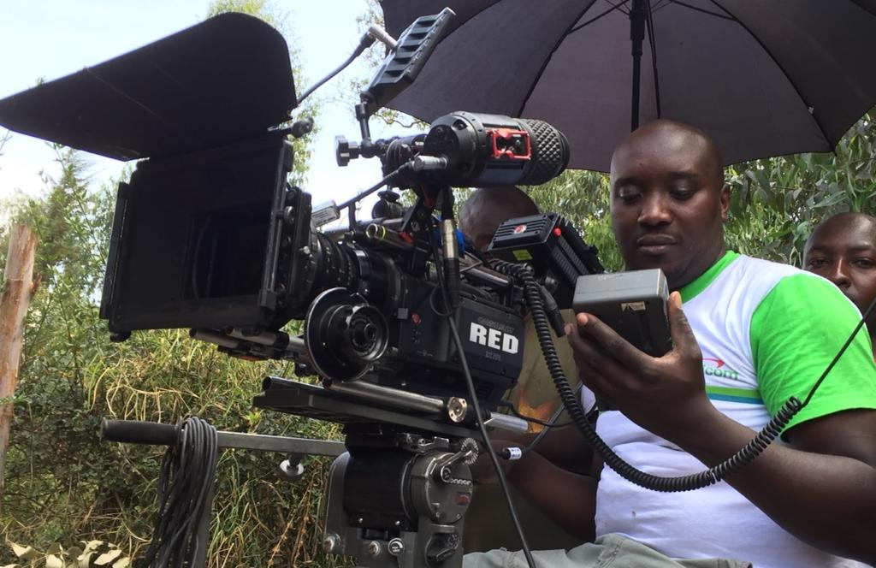
Steve has worked for over 10 years as Director of Photography/Cameraman on T.V shows, Documentaries and Features Films. He has shot numerous Documentaries in Kenya, South Africa, Mozambique, Senegal, Zambia, Brazil, Rwanda, Uganda and Swaziland including: UN Free and Equal - 2018- 2019, Permanent Persistent Poison - World Wildlife fund 2018, Wash - BBC media action 2017, The last warriors-produced by Made in Copenhagen – 2016, Train to win by sport brand Australia - 2012, Women of Blue economy- International Committee for the Development Peoples.

Steve has also shot Documentaries for: AWID, USAID, Save the Children, British Council, Safaricom and Standard Chartered Bank. He has been the DOP on numerous T.V shows including, Popo T.V drama, commissioned by Zuku 2015, Parasites T.V drama-Mnet, Dramas of life-NTV, Waridi-Mnet, Seeds of gold-NTV, and Africa Rising-Mnet.

Steve was the DOP on the interactive action Film ‘Simiyu Samurai’ which won 5 Kalasha Awards in 2013 and 2014 - and for Jongo love - the first show shot entirely using a phone and aired on the local T.V channel [NTV]. The show was developed and produced by ‘Well Told Stories’ and was well received world wide. It was featured in BBC international, The Guardian and other international media platforms.

He’s currently making his first feature film ‘Muhia & the Mountains: https://drive.google.com/file/d/18aAhGFw-VcVd6FGQ2J7EYhIVg8RVB8dl/view?ts=60a23236

